**UNIVERSITY OF IRINGA**

**FACULTY OF SCIENCE AND EDUCATION**

**DEPARTMANT OF INFORMATION TECHNOLOGY**



**COURSE NAME: INTO. TO COMPUTER GRAPHICS**

**COURSECODE: DIT-204**

**COURSE INSTRUCTOR: MR. MICHAEL MTEI**

**NATURE OF WORK: GROUP ASSIGNMENT**

**GROUP NO 4**

**GROUP MEMBERS.**

|  |  |
| --- | --- |
| ***NAME*** | ***REGISTRATION NUMBER*** |
| GLORY NAONYO | D_IT-30478 |
| NASSORO SUDI | D_IT-30959 |
| FADHILI KINGAZI | D_IT-29310 |
| REMMY KAPINGA | D_IT-30553 |
| FULBERT DEOGRATIUS | D_IT-29858 |
| BENJAMIN FREDYMKANE | D_IT-28904 |
| JAMES MWAMBASHI | D_IT-31080 |
| SALIM ALLY | D_IT-28971 |
| ANITHA NYONDO | D_IT- |

Contents

Introduction 3

Abstract 3

OBJECTIVES 4

Technology used 4

AAA logo 4

Movavi video editor 5

CONCLUSION 6

# Introduction

## Abstract

(Shining liquid soap advertisement) is type of soap that is in liquid form. As members of group number four we decide to create an advertisement of this type of soap. However there are many different technologies that are used to create this advertisement. This advertisement is in form of a short video clip that shows the product, how the product look like as well as the ingredients that found or form this type of product. Advertise like this helps organizations or companies that are specifically deals with production or supplies of such type of products

This Documentation gives details of the development process of a creation of this add to be used within a higher or more advanced establishments as well as companies. Advertisements like this help to make more profits to the companies as well as people that are responsible to create such advertisement

Products like this are used on a daily basis, and availability of advertisement like this have made our lives easier. Users are aware of availability of products as well as components that are used to create such products.

In general, the soap and detergent industry has not integrated backwards toward their raw materials. Basic raw materials come from a host of supplier companies. Caustic, fats, and oils for soap making come from chemical and agricultural processors, although some companies do own coconut plantations.

It is fairly common for the major companies to contract with other companies for toll processing. In these arrangements the soap and detergent company will buy synthetic detergent bases, send them to a second company for reaction, and have the product returned for further compounding. For example, detergent alcohols may be bought by a soap and detergent company and then toll ethylated by a petrochemical company and returned to the soap and detergent company for further processing.

## OBJECTIVES

Objectives of our advertisement is to make sure the product that we are advertise to reach as many people as we can as well as user to buy the product .with proper technology this advertisement is very simple to create as well as to convey the message to the intended people

Liquid soap can be formulated with entirely different organic and inorganic chemicals to exhibit the same cleaning power or have the same biodegradability. They also can be formulated to:

1. Maximize cleaning power

2. Maximize biodegradability

3. Minimize eutrophication potential in a specific receiving water.

4. Maximize cleaning power/unit cost.

5. Minimize air or water pollutants and solid wastes arising from the manufacturing processes.

6. To make user people are using good and quality products.

7. To protect thousands of user’s skin health

8. To protect others from a rage of infectious diseases

9. To prevent and remove the growth of bacteria

## Technology used

The technology used to create such advertisement are including AA logo, movavi video editor.

AA logo was used to create posters, vector as well as images that will appear to the advertisement t also movavi video editor was used to create a video slides as well as animation. That are in the advertisement

### AAA logo

Is a premium logo creation software used to make logo icons and templates, with AA you can create any types of website graphics or business graphics for high resolution printing.

Custom t-shirt designing, logo, button, banner for website designing and other stationary staffs can be designed and created through AA logo

As for our advertisement we used AA logo to create logos, poster as well as images that have used in the video sliding of our project

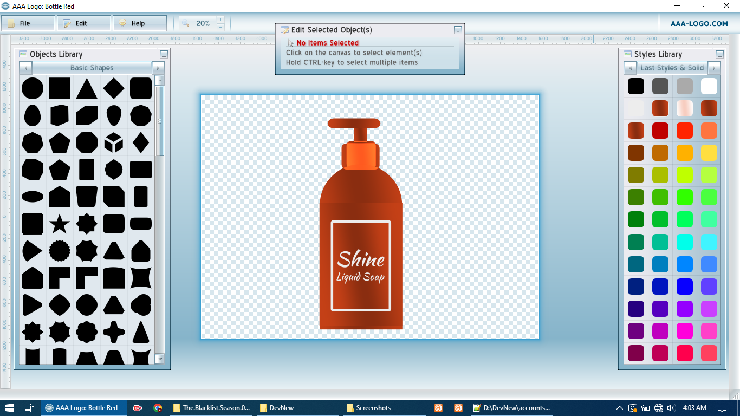

Figure

### Movavi video editor

Movavi video editor is the perfect software tool to bring your creative ideas in life and share with the world. It helps to create videos with special effects, key frame animation and ready-made intros. It’s easy to create background of the video clips as well as animation

Unlike other complex professional programs, movavi video editor doesn’t hide its broad capabilities beneath multiple layers of tabs and menus.Movavi video editor have simple interface with intuitive controls.

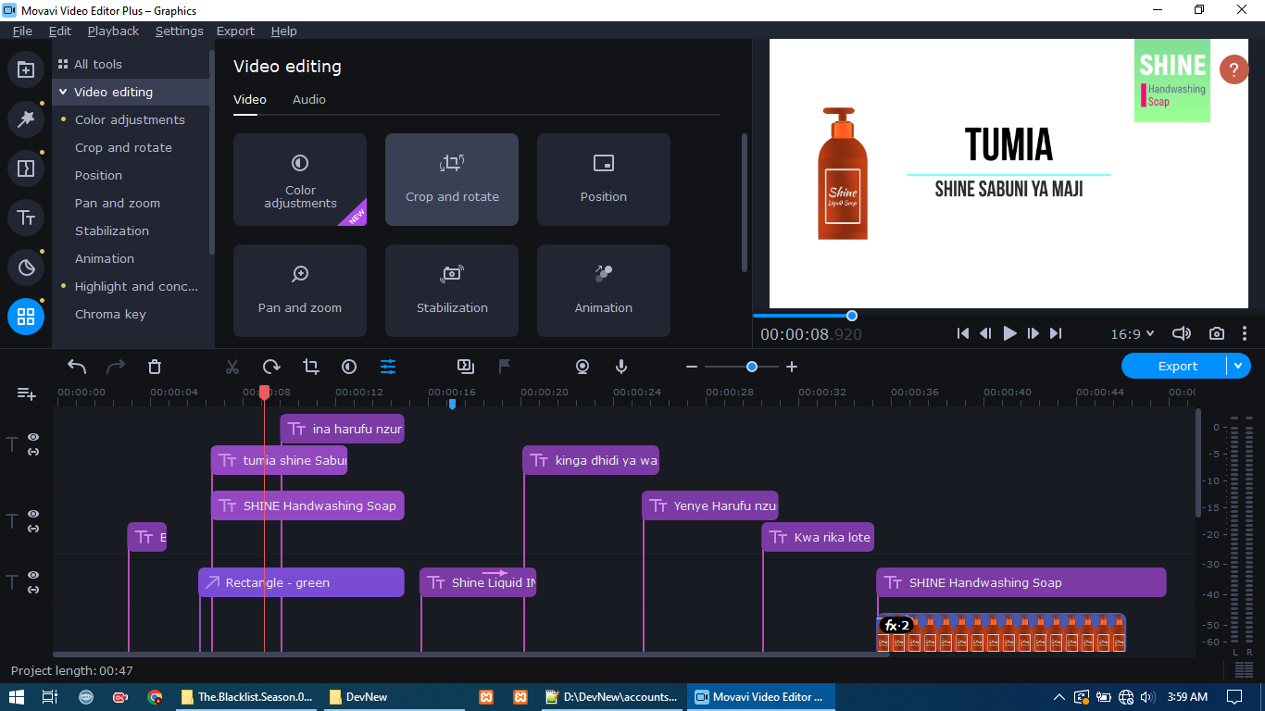

Figure

## CONCLUSION

In creations of project like this as a group helps us to gain a lot of knowledge during the process because in doing so we were able to lean different software as well as application such as AAAlogo that is used to create logos for graphics as well as movavi video editor .doing group projects like this is very fun also it strengthening our bond in learning computer graphics. We are looking forward to do more computer graphic projects in the future, by leaning this and gain its knowledge well pay off and we will be able to earn income.